***SOFTWARE REQUIREMENTS SPECIFICATION***

**Request Us & Maps**

**1.0 Introduction**

This document is meant to delineate the features of Request Us & Maps Menus for the existing application, so as to serve as a guide to the developers on one hand and as a software validation document for the prospective client on the other.

Request Us & Maps are two enhancements for the existing application called **chatrasahaya** for a web application. Our application is designed for User/Customer for requesting of required categories likes education,financial,Health to gain best education for less budget schools or free schools for the existing application.Maps can show the count for the each state based on requests completed by the users/team.

**1.1 Goals and objectives**

Overall goal of our enhancements of the existing application is to allow team/users for requesting of requests likes education,financial,Health to gain best education for less budget schools and also shows the no of requests count on the state map along with request details

**1.2 Statement of scope**

Users can submit their required needs likes education,financial,Health…from the **Request Us for Self /For Others** Page by using some fields such as **Name** -- Full Name of the requester , **Phone Number** -- Phone/mobile Number of the Requester , **Location** -- The place of the request where books,chairs,tables are needed for the schools , **Category--** Its was type of the request such as education,financial,Health **Description** -- Its was the description/overview of the needs , **Aadhar Number** -Its was unique identity number of the requester, **Documents** --- Proof of the documents needs to be uploaded here.

**Count in Maps :** Our Team can view the number of the places count where services are provided by state level in the Map indication

**1.3 Software context**

The software is placed for the users to raise the request by proof of documents,location which can be helpful to less budget schools

**1.4 Major constraints**

1. A full internet connection is required for Requesting of Tables, Chairs, Books..by using Request US and also to view the Maps Count and its details to run properly

2. Location,Requester Details and Other Proof of Documents are also required

**2.0 Usage scenario**

**2.1 User profiles**

The principal Actors in this application are End Users and Internal Team

**2.2 Use-cases**

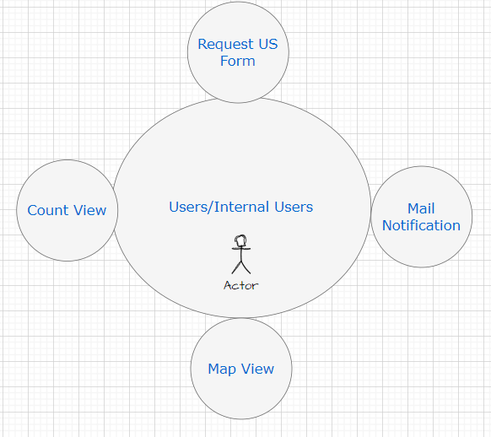

**User:**

1. **Request Us**

If customer wants to request us the required needs to the low budget schools , this page can be useful to submit the details of location,proofs.

1. **Mail Notification**

Our internal team can receive the mail after submitting the request us details

1. **Map View**

User can know the no of requests completed in the map by state level

1. **Count View**

User can know the details of the each count like request location,requester name, request items etc…

**2.3 Special usage considerations**

**Functional Requirements :**

**“Request US”** sub menu in the home page

1. **Request US/Request Page** : End users can select the option “For self” or “For others” which means request can be submitted for themselves or for the others , By default “For self” option should be selected then Request Form will contains the fields such as **Name** -- Full Name of the requester , **Phone Number** -- Phone/mobile Number of the Requester , **Location** -- The place of the request where books,chairs,tables are needed for the schools , **Category--** Its was type of the request such as education,financial,Health **Description** -- Its was the description/overview of the needs , **Aadhar Number** -Its was unique identity number of the requester, **Documents** --- Proof of the documents needs to be uploaded here. With **Submit** Button to submit the request and also cancel Button to **cancel** the request or go back to the previous page. Alerts will be shown for the each field if the user enters the wrong/Invalid information while clicking on submit button.
2. **Mail Notification:** After End users clicking on Submit button with the valid data , A mail will be sent to the **chatrasahaya** team mail id to get to know the requester details.

1. **Map View :** In the Request Us Page , A counts of the requester successfully severed on each state wise in the Map, Count view will be displayed when user clicking on Counts in the Map.
2. **Count View :** After user clicking on counts in the map view , a popup will be displayed in the tabular form with the requester details such as Name,Phone Number,Location,Category,Description,Aadhar Number, Images View link and also user can close this popup by clicking on close icon in the popup

**Non-Functional Requirements:**

1. Design of the application should be good and to store the requester details full secure

**3.0 Data Model and Description**

**3.1 Data Description**

The enhancements Data Objects consist in Application are Request Us Form,Map View,Count View and Mail Notification

**3.1.1 Data objects**

Data object 1: **Request Us**

Attributes of Request Us: Request ID, Name, Phone Number,Location, Description,Documents Path

Data object 2: **Mail Notification**

Attributes of Mail Notification: Notification ID, Notification Name,Notification To Address, Notification From Address , Notification Body,Notification Status

Data object 3: **Map View**

Attributes of Map View: State ID, State Name, Counts

Data object 4: **Count View**

Attributes of Count View: Count ID, State ID, State Name, Count Details

**3.1.2 Relationships**

1. Relationship between Users and Request Us: **Submit**

Users can Submit the request items by using the Submit button in the Request Us Page

1. Relationship between Request Us and Mail Notification: **Mail Trigger**

After submitting the request items details by using page , internal team will get the mail notification about the request submitted by the user

1. Relationship between Request Us and Map View: **Counts**

Users can the view the count of the requested counts by state level in the Map view

1. Relationship between Map View and Count View: **Details View**

Here, Users can view the count details on the state such as request name,request location and proof of documents in the popup.

**Same details can be shown below in the tabular Form:**

|  |  |  |
| --- | --- | --- |
| **Page/Field** | **Page/Field** | **Relationship** |
| Users | Request US for self/For Others | Submit |
| Request Us | Mail Notification | Mail Trigger |
| Request Us | Map View | Counts |
| Map View | Counts | Details View |

**3.1.3 Complete data model**

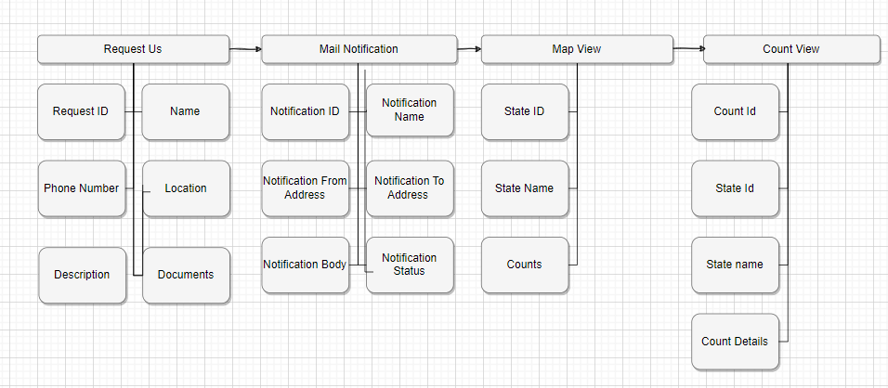

**3.1.4 Data dictionary**

|  |  |  |  |
| --- | --- | --- | --- |
| **Request Us For Self or For others** | **Mail Notification** | **Map View** | **Count View** |
| Customer ID: Int | Notification ID : Int | State ID: Int | Count ID: Int |
| Name: String | Notification Name: String | State Name: String | State ID: Int |
| Phone Number: BigInt | Notification To Address : String | Count: Int | State Name:String |
| Location: String | Notification From Address : String |  | Count Details : Table with Request Name,Request Phone Number,Location,Description,Documents View |
| Description: String | Notification Body: String |  |  |
| Documents: Img,Pdf Uploads | Notification Status  : String |  |  |

**4.0 Functional Model and Description**

**4.1.** **Description of Major Functions**

Major functions of Our Enhancements for our existing Application

* Request Us Form
* Mail Notification ---Sending of the Mail Notifications for the Request to our team
* Map View -- To show the counts by the state level in the Map
* Count View --- To view the details for the each service provided with the images

**4.1.1 Request US Form**

User can Submitting of the Request of needs for the schools for self/For Others

**4.1.2 Mail Notification**

Internal User can receive the Mail Notifications for the Request to our team

**4.1.3 Map View**

User can see the no of requests count state wise on the map

**4.1.4. Count View**

User can view the details for the each request/service provided with

the requester details and images in this page

**4.2 Software Interface Description**

The software interface(s) to the outside world is(are) described.

**4.2.1 External machine interfaces**

Interfaces to other machines (computers or devices) are described.

1. Operating System: Windows 11
2. Microsoft Visual Studio
3. WordPress PHP on Go-daddy itself
4. Microsoft SQL Server Management Studio
5. Java/python Development Toolkit.

**4.2.2 External system interfaces**

1. Users needs to have stable internet connection to access the application and requester details to submit the request

**4.2.3 Human interface**

An overview of any human interfaces to be designed for the software is presented.

**5.0 Restrictions, Limitations, and Constraints**

Special issues which impact the specification, design, or implementation of the software are noted here.

1. A full internet connection is required for the application to run properly.
2. Customer data security for requester details and proof of documents should be more secure and confidentiality.